Box Pusher

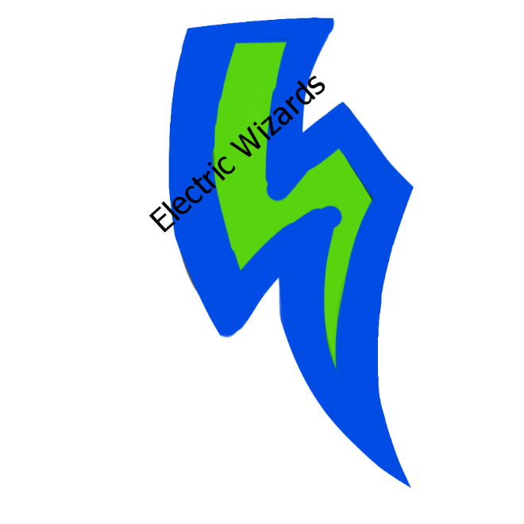



Revision: 1.0.0

License

Overview

Theme / Setting / Genre

Core Gameplay Mechanics Brief

Targeted platforms

Monetization model

Project Scope

Influences (Brief)

-Influence #1

-Influence #2

The elevator Pitch

Project Description (Brief):

What sets this project apart?

Core Gameplay Mechanics (Detailed)

- Core Gameplay Mechanic #1

- Core Gameplay Mechanic #2

- Core Gameplay Mechanic #3

- Core Gameplay Mechanic #4

Story and Gameplay

Story (Brief)

Story (Detailed)

Gameplay (Brief)

Assets Needed

- 2D

- Textures

- Sound

- Code

# Overview

## Theme / Setting / Genre

-Puzzle game that revolves around pushing and placing boxes into specific areas to unlock gates to progress.

-Game is a 2D platformer sidescrolling puzzle game

## Core Gameplay Mechanics Brief

- Pushing

- Grabbing

- Jumping

## Targeted platforms

-PC

## Monetization model

One-time payment of a certain amount ($2.49 CAD)

## Project Scope

Project time period is expected to take 3 months

Team size will be three(3) people. Jahn Ramjahn, Marc Molano, Pavel Levin

## Influences (Brief)

### -Influence #1

Geometry Dash

-Game that revolves around a jumping square, main influence. Simple game and mechanic, yet fun and challenging. Highly based on good, simplistic yet challenging level design.

### -Influence #2

Limbo

-Simplistic puzzle game, main influence on the puzzle side of Box Pusher.

## The elevator Pitch

Box Pusher is a puzzle based platformer with the simple mechanic of pushing, pulling, and grabbing boxes into specific spots to unlock gates to progress through the levels. It’s a very level design oriented game that requires logic and memory to complete multiple puzzles in a level to unlock the next stage.

## Project Description (Brief):

Box Pusher is a puzzle based platform that makes the player push, grab, reposition objects to place them in the needed locations in order to proceed to the next level. The player can grab objects, push them, and activate buttons to progress through the game. The game is level design oriented, and requires you to keep track of how many sections of the level need to be unlocked in order to proceed to the next stage.

# What sets this project apart?

-It’s an object placement game, usually puzzle games don’t incorporate the placement of objects in the puzzles.

-Somewhat physics oriented, with the pushing and grabbing being the main mechanics

-Simple concept, yet requires multitasking

## Core Gameplay Mechanics (Detailed)

### - Core Gameplay Mechanic #1

- Pushing objects into positions

Your job is to put objects into the necessary locations before you can unlock the next level. Without all the objects in the correct places, the gate will not open.

### - Core Gameplay Mechanic #2

- Sliding

The character’s movement is based on sliding as a square. The friction acts as a mild slowing agent, but the character generally slides in order to move.

### - Core Gameplay Mechanic #3

- Grabbing objects

If you cannot push objects into position, you can grab them and carry them with you to the needed locations.

### - Core Gameplay Mechanic #4

- Jumping

You can jump to reach otherwise unreachable areas and you can jump while holding objects with the grab mechanic.

# 

# Story and Gameplay

## Story (Brief)

-You are a cube that is trying to navigate the environment to get to the end game, a gold coin. Once you pick up the gold coin, you win.

## Story (Detailed)

## Gameplay (Brief)

-The player pushes boxes and objects into certain areas and upon pushing all objects into the necessary positions, unlocks the gate to the next level.

# Assets Needed

## - 2D

## - Textures

- Environment Textures, character sprite, and puzzle box sprites.

## - Sound

- Sound List (Ambient)

-Ambient

- Sound List (Player)

- Character Movement Sound List

Slide sound

- Character Hit / Collision Sound list

Grab sound, click sound(for puzzle completion)

## - Code

- Character Scripts (Player Pawn/Player Controller)

- Ambient Scripts (Runs in the background)

- Level puzzle unlock/lock script